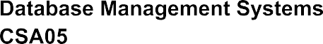

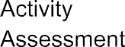
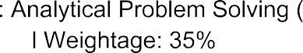

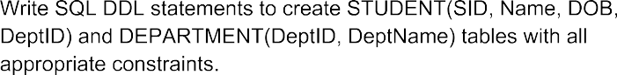
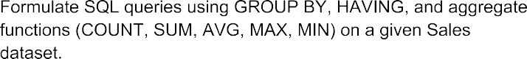

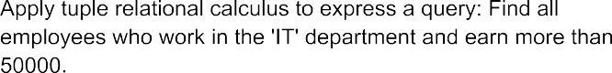

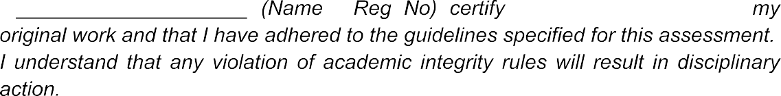
G Vyshnavi
G Vyshnavi (192525260)

1.Apply relational algebra operations (σ, π, ∪, -, ×, ⋈) on the given Employee and Department relations to retrieve required records.

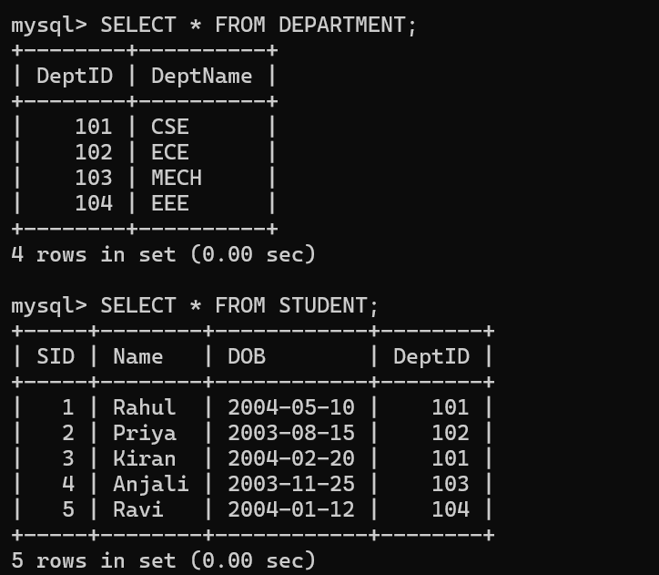

2.Write SQL DDL statements to create STUDENT(SID, Name, DOB, DeptID) and DEPARTMENT(DeptID, DeptName) tables with allappropriate constraints.

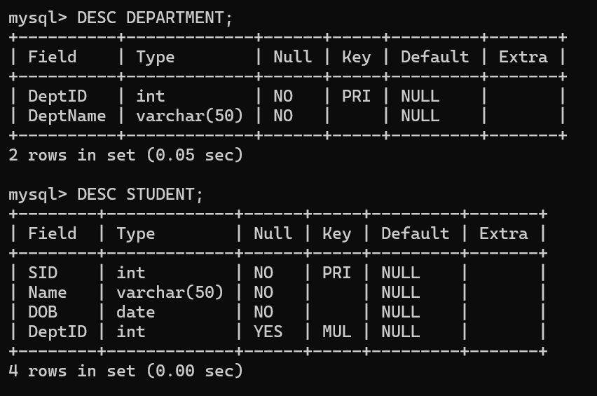

- Formulate SQL queries using GROUP BY, HAVING, and aggregate functions (COUNT, SUM, AVG, MAX, MIN) on a given Sales dataset.
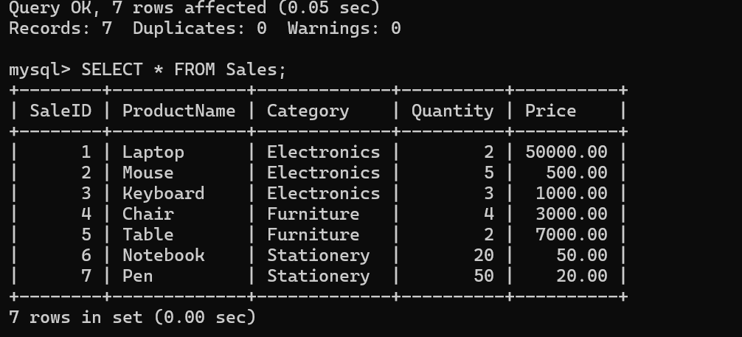

- Write a correlated sub-query to find employees earning more than the average salary of their own department.
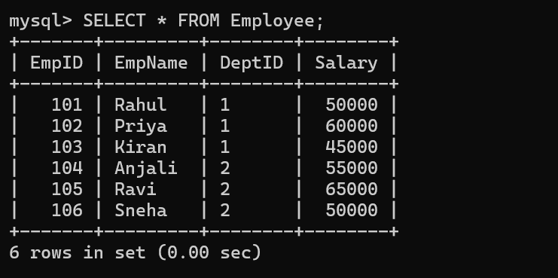

- Apply all types of JOIN operations (INNER, LEFT OUTER, RIGHT OUTER, FULL OUTER, CROSS) on Employee and Project tables.
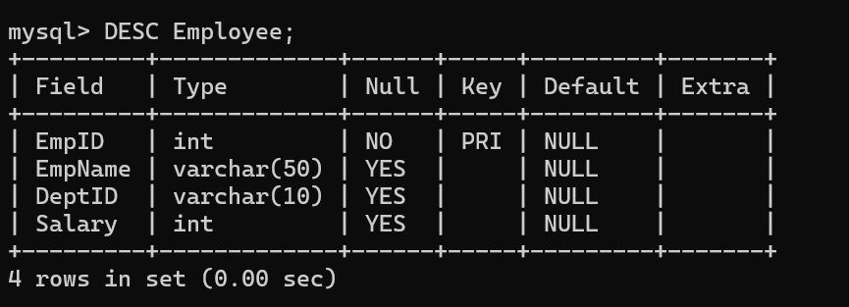

- Create a view &#39;DeptSalaryView&#39; that displays department name, total employees, and average salary. Write a query on this view.
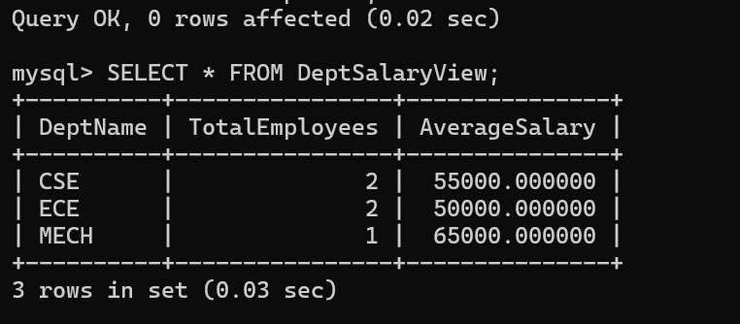

- Construct a relational algebra expression for the following: Find names of students who are enrolled in all courses offered.
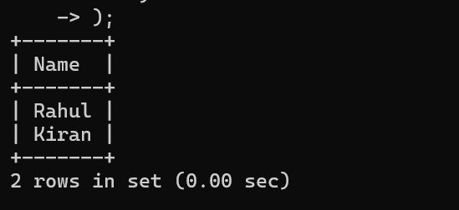

- Write SQL DML statements (INSERT, UPDATE, DELETE) with integrity constraint enforcement for a given scenario.
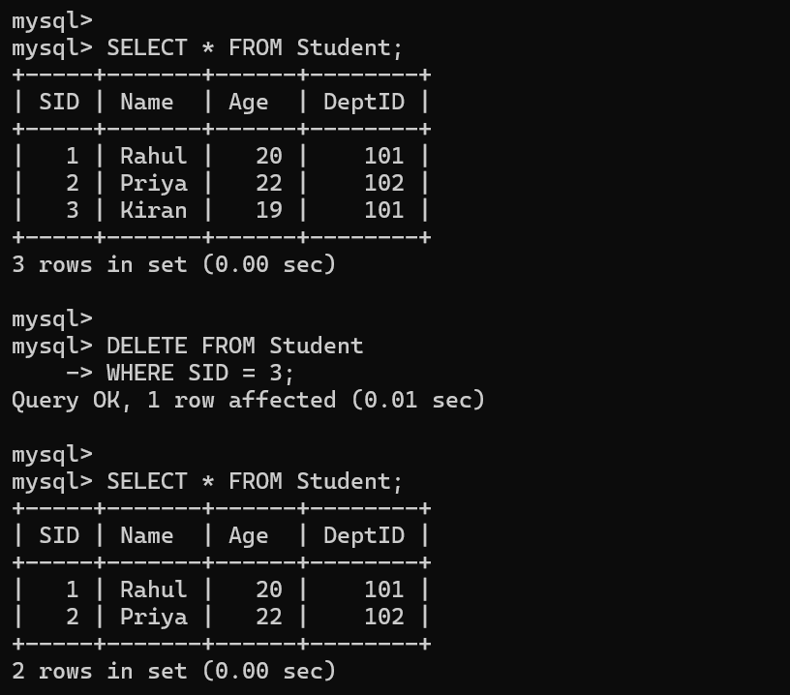

- Apply tuple relational calculus to express a query: Find all employees who work in the &#39;IT&#39; department and earn more than 50000.

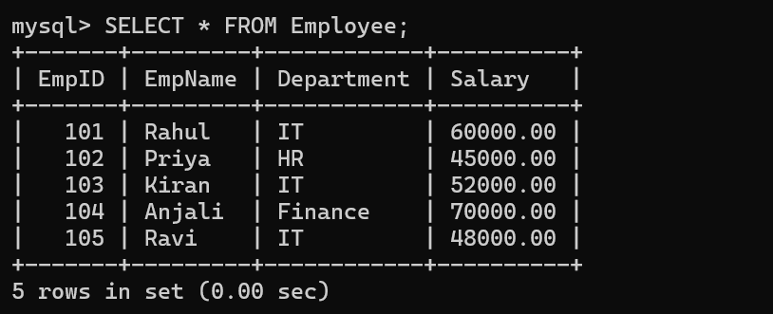

- Design a relational schema for an Airline Reservation System and write 5 SQL queries demonstrating joins, sub-queries, and views.

